coBGP routing

Routing telephone calls by embedding prefixes in IPv6 addresses - Info page
- Code and configuration

What?
- It is a telephony routing system (phase 1).
- The routing system resembles Cisco Service Advertisement Framework (SAF), but instead of proprietary EIGRP, it uses standard BGP (we call it Connection Oriented BGP (CO-BGP)). It also resembles Telephony Routing over IP (TRIP) protocol, but is much simpler.

Why?
Routing: Not all networks are IP capable.

Network overview (**bolded** components are standardized)
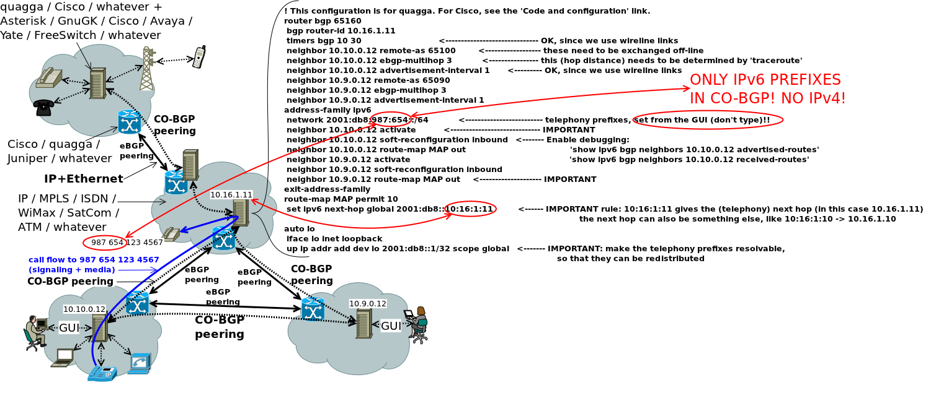Network overview

Functionality overview

Phase 1: Only basic telephony prefixes, nothing fancy
- A basic example of a telephony prefix is: 2001:db8:987:654::/64. This corresponds to telephony prefix 987 654.
- A basic telephone number prefix is: 2001:db8:987:654:321:1234::/96. This corresponds to telephone number 987 654 321 1234.
- Unless otherwise agreed, you should only advertise the prefixes (not the full numbers).

Implementation ideas
Free and open software is available on this page for the bolded components, see the “Code and configuration” link.
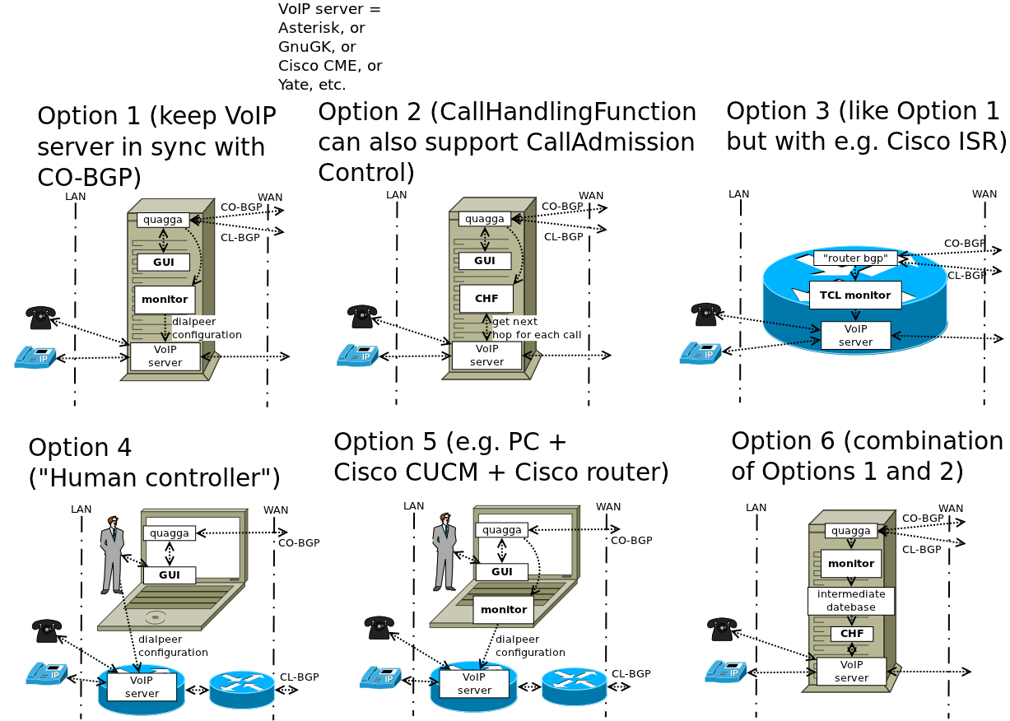Implementation

What is the best implementation option?
- If you like Cisco (and don't want to couple call routing with CAC/MLPP), 3-5 are good.
- Else if you must couple CAC/MLPP with call routing, use 6 (better than 2).
- Else if you can, use 1 (provides fastest call handling).
- Finally, if you have no other option, use 2. Make sure that the call handling is fast enough in this case.

GUI (for quagga, can be modified to use Cisco)
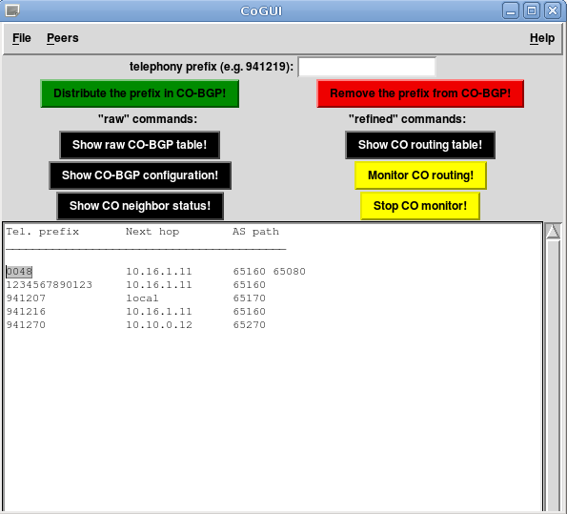
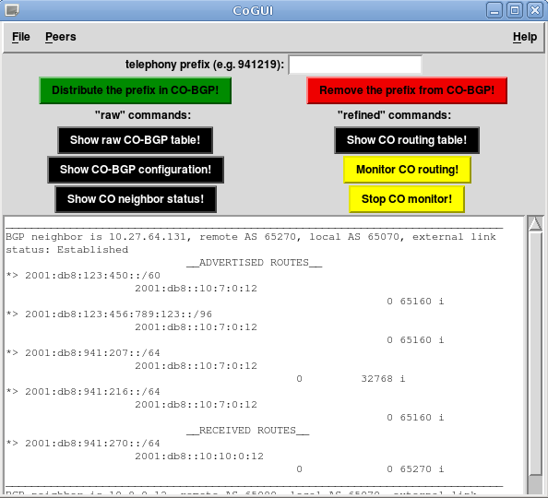
All comments are warmly welcomed! Send them to: (address pending)

